How to add new videos to the   
Central Okanagan Sports Hall of Fame kiosk

**\*Do not connect the Raspberry Pi to the internet, updates may break the program**

1. Plug a USB keyboard into the Raspberry Pi (small computer in the podium) and press Alt+F4 to close the program
2. Unplug the USB memory stick from the Raspberry Pi
   * No need to eject it or turn it off
   * If you want to eject it click the up arrow in the top right of the Raspberry Pi and select the “Lexar USB Flash Drive (Lexar)  
     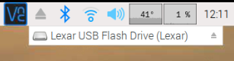
3. When at your computer, copy the new videos into the folder labeled “Videos”

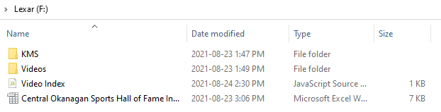

1. Follow the “year - Name.mp4” naming convention when adding the new videos
2. Open “Video Index.js” in Notepad



1. Copy and paste:  
    { fileName: "2019 - Tania Jones.mp4", keywords: "track and field, running" },  
   making sure the new line stays under: const videos = [
2. Replace “2019 - Tania Jones.mp4” with the new video’s filename
   * \* The filename must match the video filename in the “Videos” folder exactly or it won’t work
   * \* The filename must stay within the quotation marks

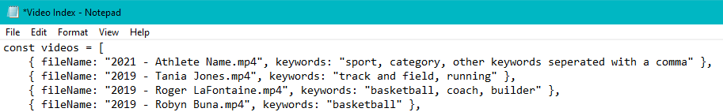

1. Add any keywords within the quotation marks after “keywords:” this can be sport, category, award, names, anything you think the user will type in to search for the video separated with a comma
2. Save the .js file
3. Update the “Central Okanagan Sports Hall of Fame Inductees” Excel spreadsheet with the same information and save
   * This is just for tracking purposes and doesn’t affect the program
4. Return the USB memory stick to the kiosk and plug it into the Raspberry Pi
   * Click cancel when the “Removable medium is inserted” pop-up shows

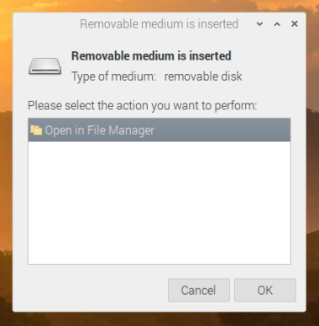

1. Restart the program by clicking the KMS logo in the top left of the touchscreem  
   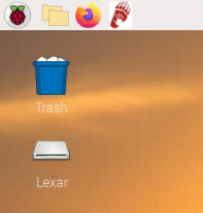
2. The newest videos should show under the search bar
   * If not, go back and make sure the filenames have been added correctly and there are quotation marks around both the filename and keywords

